CS 470: Database Systems

Prepared by Dakota Carpenter, Sri Sai Chitikina, Carla Flores Garcia, and Rahul Ravula

For Professor Anjum Razzaque

Due May 5, 2023

Dakota Carpenter worked on the JDBC code, specifically the parts regarding privileges and did some debugging. He also prepared the GitHub we used for the project and made this report. Sri Sai Chitikina worked on the JDBC code, SQL database, and the ER diagram. He also researched Java Servlets and debugged the Java code and SQL. Carla Flores Garcia worked on the JDBC code, SQL database, and the ER diagram. She worked on debugging the Java code and SQL as well. Rahul Ravula worked on the JDBC code, SQL database, and ER diagram. He has also been debugging Java code and SQL.

Our project models an employee timeclock system. The entities in our database include Owner, Employee, Department, Shift_Type, Employee_Shift_Schedule, and Log_Time. Relevant attributes include owner_ID, employee_ID, department_name, shift_ID, shift_schedule_date, login_time, and logout_time. This is our ER diagram:

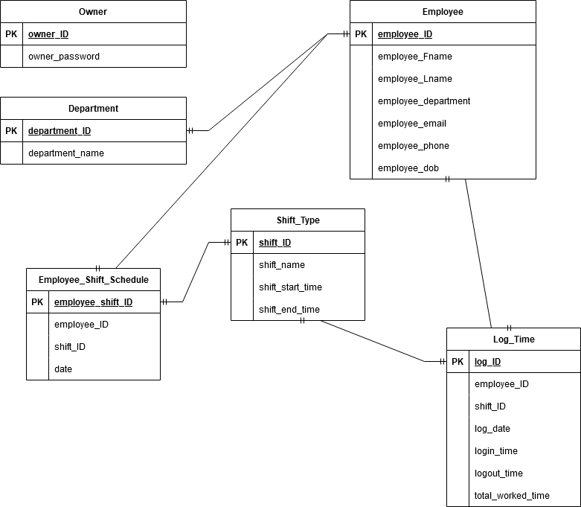

Conceptual view: In our project, there are 2 levels of privileges for stakeholders. Owners have read and write privileges while employees have read-only privileges. The rest of the conceptual view is represented by our ER diagram above.

External view: We use many different types of views in our project to represent the external view. The owners have 3 different views to choose from. The first one is the employee’s daily status view. This view uses employee_ID, employee_Fname, employee_Lname, logout_time, and login_time to show if an employee is on time or late. The second view uses employee_ID, employee_Fname, employee_Lname, log_date, and total_worked_time to show an employee’s weekly hours. The third view uses employee_ID, employee_Fname, employee_Lname, log_date, and total_worked_time to show an employee’s weekly status. There are also views that employees can access such as their weekly hours view and their weekly status view. The difference between the owner view and employee view is that the owner can choose any employee to view while the employee can only view their own data.

Internal view: In our project, the internet view is represented by the various tables mentioned above as well as their relationships between each other that can be seen in the ER diagram. The keys to each table also have data types associated with them to help the user understand how they are being stored.